Data Presentation Tips
Too many charts, too little time! There are many more types of graphs than described here. These are the most common charts used in quality improvement. Additional help resources are listed below.
Getting started
Start with Excel! healthAlliance offers beginner and intermediate courses.
What question do you want to answer? Will your audience be able to obtain the answer from the graph?
How much data should be reported?
Quality Improvement is not research. Poorly performing processes need fewer data points since flaws are detected earlier. For example, fewer charts would be needed if a discharge documentation audit showed 30% error rate than if there was a 4% error rate. In these cases, 50 charts would show 15 and 2 errors, respectively.
The human brain has difficulty processing more than 50 data points, so aggregate large data sets into smaller subsets. For example, if reporting the number of ED visits over 20 years, use annual numbers instead of monthly numbers. If monthly detail is important due to seasonal variation, scale back the number of years or report quarterly.
Choosing the right graph
Graph type | When used | Healthcare Example
Bar chart  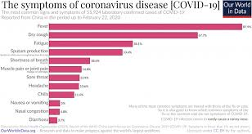 | Compares categorical data using rectangular bars plotted vertically or horizontally.  Consider using horizontal bars when more than 9 data points.  DO NOT USE 3-D BARS, CONES, OR CYLINDERS!  These can be confusing to interpret. Stick with 2-D. | Number of patients by post code. Best to order highest to lowest or logically (alphabetical or numerical order).
Stacked bars  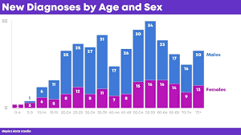 | Show the relationship between categories.  Be cautious with stacked bars. Limit the number of categories to 5. Use a run chart if reporting changes in relationship over time. | Number of patients by sex.
Pareto chart  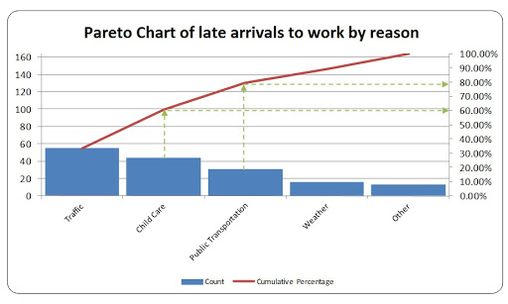 | Focus on key problems. The bars are ordered highest to lowest and the cumulative percentage is shown as a line and uses the secondary y-axis on the right. | Reasons for breaching lab test ordering guidelines
Run chart or line graph  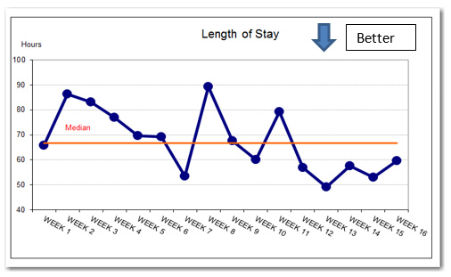 | Display data over time.  Time is always displayed on the X-axis. The Y-axis reports the variable that changes or doesn’t change over time.  A run chart should have at least 10 data points and no more than 50 data points.  May report median average. | Monthly volume of clinic appointments
Scatter plot  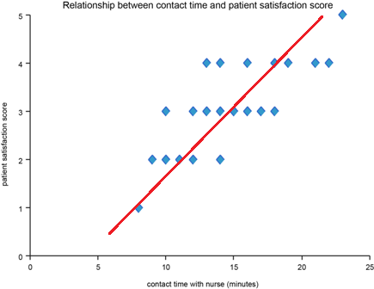 | Displays the relationship between two variables.  Excel can add a Trendline (red) and the r² value, which measures the trendline reliability. The closer the r² value is to 1, the stronger the relationship between the variables. | Percentage of staff attending moving and handling training versus number of injuries
Histogram  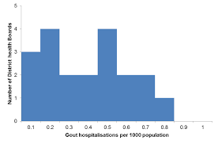 | Displays the distribution of data counted in ‘bins’.  The example from HQSC shows the number of DHBs and their Gout hospitalisations per 1000 people.  Histograms can easily be created with an Excel plug-in for the Analysis ToolPak. | # days on waitlist. Bins might in weekly increments
Pie Charts  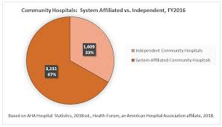 | Displays components of a whole.  Pie charts are discouraged and the relative components can better be reported in bar graphs. If you insist on using a pie chart, limit the number of slices to 5. The most significant slice can be highlighted, but do not use multiple shades or colours. | Population ethnicity
Statistical Process Control (SPC) chart  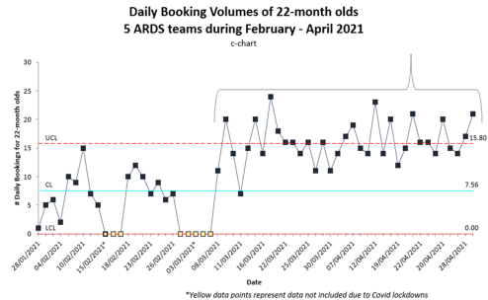 | To monitor, control, and improve process performance over time, and indicate whether the change is statistically significant. There are many different types of SPC charts and the correct chart depends on the type of data that is being reported. SPC charts using 3 standard deviations for control limits should have at least 20 data points. If less than 20 but at least 15, use 2 standard deviations.  SPC charts report the mean average. | Hospital admissions over time.

Other suggestions
“A picture is worth 1,000 words.”
Every graph should tell the complete story, with titles, labels, axis headings and annotations telling:
  - What period of time does the data reflect?
  - What is the data source?
  - What population is being reported, what are the exceptions?
  - How much data is represented (e.g., n=x)

- Choose appropriate chart settings. For example, if minutes are reported on the y-axis, consider setting the axis increments in 30, 60, 90, etc.
- If comparing two graphs, make sure the y-axes are the same for both.
- Use colour to accentuate but don’t overwhelm the reader. Keep it simple with monochrome so the differences are still apparent if it is printed in black and white or someone in the audience is colour-blind (8% men, 0.5% women).
- LESS IS MORE! Avoid grid lines and scale, or use a lighter font
- Sense-check your graph – if there is an outlier, possibly the data is an error.

Sources for this tip sheet
These tips were based on books: “The Wall Street Journal Guide to Information Graphics” and “The Memory Jogger”, websites: New Zealand Heath Quality and Safety Commission (HQSC) and East London Foundation Trust (ELFT), and also wisdom collected from some amazing colleagues over more than a decade of healthcare IT and quality improvement. The chart images were obtained from HQSC, internal WDHB projects and the Internet.

For more information
https://healthdataviz.com Kathy Rowell’s blog and newsletter provide tips on telling stories with data.
WDHB Knowledge and Research Centre (KRC) can provide advice regarding research and guidance when ethics approval is required. KRC also has a statistician who can provide advice.
WDHB i3 data analysts and project managers can assist with data questions. For general enquiries, email i.3@waitematadhb.govt.nz.

